

Name: Parthiban A/L Ramasamy

Login ID: parthiban@oasis-portal.com

Course title: The Tourism and Hospitality

Subject Code: BHM04

Submitted date:

18 sept 2017

**Table of Contents**

|  |  |  |
| --- | --- | --- |
| No | Details | Page |
| 1 | Executive Summary | 2 |
| 2 | Introduction | 3 |
| 3 | Assignment Question  Part 1 | 4 – 9 |
|  | Part 2 | 10-13 |
|  | Part 3 | 14-20 |
|  | Part 4 | 21-23 |
| 4 | Conclusion | 24 |
| 5 | References | 25-26 |
| 6 | Appendix | 27 – last |

**Executive Summary**

In this module, I have learned the Tourism and Hospitality. Tourism is not a simple topic and hospitality is also not a small topic to explain and to understand. The Tourism and Hospitality can be explain in many ways because this tourism and hospitality are almost very popular in worldwide. Most probably in this module I’m going to explain more detail about the Tourism and Hospitality. I will be able to understand the Tourism and Hospitality and also will explain the aspects of the questions in this part. First of all, I’m going start the module by define the Tourism and Hospitality while explain my understanding about Hospitality industry. Then I will brief on different type of Tourism categories and also will a deep definition about tourism. By the way I also able to describe the lodging accommodation and types of Hotel accommodation in this module. Last but not least I will explain the Significant of Entertainment in this industry

**Introduction**

What do meant by tourism? In my opinion Tourism is a dynamic and competitive industry that requires the ability to adapt constantly to customer’s changing needs and desire, as the customer satisfaction, safety and enjoyment. Particularly the focus of tourism business. Hence marketing of the enjoyable and other features of a travel destination and provision of facilities and services for the pleasure of travellers (tourists). Furthermore tourism comprises the activities of person travelling to and staying in place outside from usual environment for not more than one consecutive year for leisure business and other purposes. In addition tourism that takes full account of its current and future economic, social and environmental impacts, addressing the needs of visitor. Well,

Hospitality is about providing food, drink and accommodation. It’s also involves entertainment, fitness and leisure workers.  The hospitality industry is much broader than the other industries. But this industry applies to nearly any company that focused on customer satisfaction. This industry relies entirely on customer being happy. The hospitality industry is there servicing business conducing another significant branch in the economics of the country. Associates many type of industry such tourist, the transportation and food servicing.

**Assignment Questions**

**Examples:**

Assignment question in this part contain 4 questions

**Question 1**

Define the Tourism and Hospitality.

Explain your understanding about Hospitality industry.

**Tourism**

Meaning of tourism – comprise the activities of person traveling to and staying in places outside their usual environment for not more than one consecutive year (<1 year).

|  |  |
| --- | --- |
| Tourism | * Funs |
| Tour | * Voyage/trip * Traveling for a purpose |
| Tourists | * Excursionist * Tourist |

What is tourism?

Activities or actions of individual traveling to and staying in places outside their usual environments for not more than one consecutive year for some purposes such as following below;

* Business
* Leisure
* Other purposes

Tourism is also a composite of activities, services, and industries that deliver a travel experience, transportation, and accommodations, eating and drinking establishments, shops, entertainments, activities facilities, and other hospitality services available for the individuals or groups that are travelling away from home.

* Comprise the activities of persons travelling to and staying in places outside their usual environments for not more than one consecutive year.
* Voyage/trip
* Travelling for a purpose
* Excursionist
* Tourists

**The importance of tourism**

Tourism is very important, eve vital, sources of income for many regions and countries. Its importance was recognized in the Manila Declaration on World Tourism of 1980 as an activity essential to the life of nations because of its direct effects on the social, cultural, educational, and economic sectors of national societies and on their international relations.

Tourism is also brings in large amounts of income into a local economy in the form pf payments for goods and services needed by tourists, accounting for 30% of the world’s trade of services, and 6% of overall exports of goods and services, it also creates opportunities for employments in the services sector of the economy associated with tourism.

The services industries which benefits from tourism include transportation services such as airlines cruise ships, and taxicabs; hospitality services such as accommodation, including hotels and resorts; and entertainments venues, such as amusements parks, casinos, shopping malls, music venues, and theatres. This is in addition to goods bought by tourists, including souvenirs, clothing and other suppliers.

The services industries which benefit from tourism:

* Transportation services such as airlines, cruise, ships, and taxicabs
* Hospitality services such as accommodations, including hotels and resorts
* Entertainment venues such as amusement parks, casinos, shopping malls, music venues, and theatres
* Additional to goods bought by tourists, including souvenirs, clothing and other supplies.

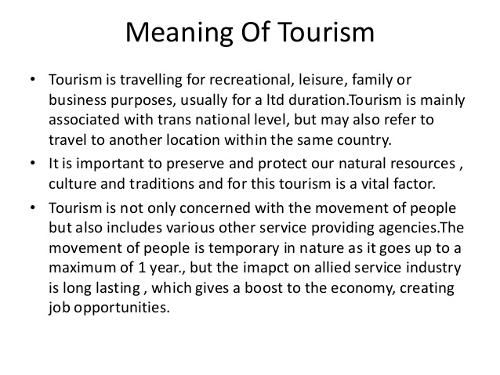

Figure 1

What is hospitality?

Providing services or materials to peoples that is away from home with an agreed time and prices

Entertaining guest with courtesy and warmth

Hospitality

The friendly reception and treatment of strangers

“House of rest” for travelers

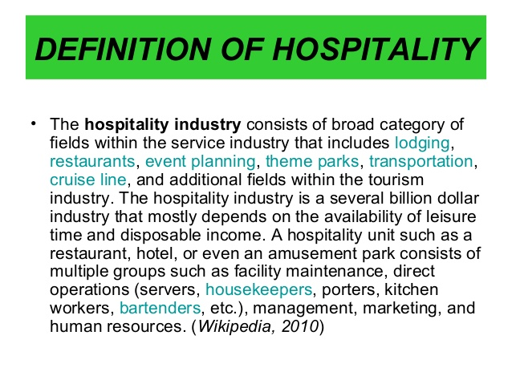

**Components of the tourism and hospitality industry**

Lodging industry/hotel industry

Food services industry

Travel & tourism industry

Recreation

The following below shows the simple understanding of hospitality industry

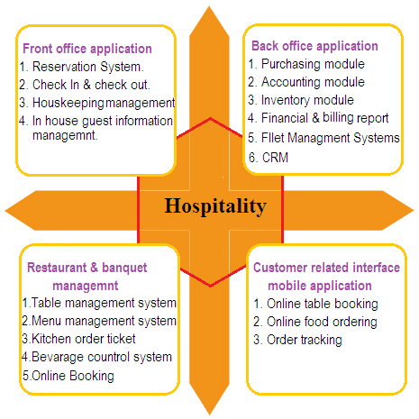

**Question 2**

Brief on different type of Tourism categories.

Define Tourism

The tourism is one of top money generating sector in worldwide. This tourism industry can be develop day by day. As a concept has come a long way today and the activity has been classified into different type of categories.

**The different type of tourism categories are following bellows.**

**Recreation tourism  
Cultural tourism  
Nature tourism  
Pleasure tourism  
Sport tourism  
Religious tourism  
Medical and health tourism  
Adventure tourism  
Educational tourism  
Shopping tourism**

**Recreation Tourism**  
-It’s a different from normal environment.  
-People who likes have fun and relax their self by having tour.   
Example: Beaches, theme park(Legoland)   
 **Cultural Tourism**  
-To improve their knowledge on cultural and history of culture and different culture.  
-Attending festivals, ceremonies to get better knowledge of other people believe of culture.  
Example: India and Mekkah.  
  
**Nature Tourism**  
-People who love the nature   
-Different type of seasons.   
Example: China for September month to enjoy the flowering season.

**Pleasure Tourism**  
-To refresh souls and spirits  
-Yoga workshop and detox vacations  
Example: Purple Valley, Assagoa, Goa

**Sport Tourism**  
-Some peoples who travel for enjoying the sport season  
-People who participate in sports  
Example: Fifa world cup 2014 in Brazil  
  
**Religious Tourism**  
-Some race must have to go certain places to complete their religious believes.   
Example: For Indians Kaasi in India , for malays Mekkah.  
  
**Medical and Health Tourism**  
-To get treatment from overseas.  
-Some Ayurveda treatments  
Example: US, India and Singapore  
 **Adventure Tourism**   
-That is catered for those who want to do more than just visit regular tourist’s sites.   
-Challenging activities   
Example: Mountain climbing & wild water rafting  
  
**Educational Tourism**  
-Pursing studies  
Example: Students select better university in worldwide.  
  
**Shopping Tourism**  
-Desire to shop  
-Those go loves to shopping  
-cheapest price  
Example: For the jewelers, accessories and clothes India is best place (for Indians)

**Tourism**

Tourism is also a composite of activities, services, and industries that deliver a travel experience, transportation, and accommodations, eating and drinking establishments, shops, entertainments, activities facilities, and other hospitality services available for the individuals or groups that are travelling away from home**.** There are a lots of factor affecting tourism.

**Factor affecting tourism**

Important factors that affect the developments of the tourism are as follows:

* Environmental factors: Good climate, Beautiful scenery, and etc.
* Socio-economic factors: Accessibility, Accommodations, Amenities, Ancillary services, and etc.
* Historical and cultural factors.
* Religious factors
* Others factors

**Main factor influencing the growth of tourism**

1. **Environmental factors**

Two main environmental factors that have led to the growth of tourism:

i) **Good climate**

Good climate is one of the most important features of attraction for any tourist place.   
Pleasant climate with warmth and ample of sunshine attracts tourists who come from the temperate and colder regions. For examples, most of the sea-side resorts in U.S.A and U.K are located on a warmer southeast. On other hands, people from summer areas migrates to cooler regions to seek pleasure of cold fresh environment. For instance, in India places like Lonavala, Mahabaleshwar near Mumbai, Kullu and Manali, Shilong, Kashmir, so on are well-known for their cool and pleasant climate. Other countries with cooler that attract tropical tourists are Switerzland, Sweden, etc.   
  
ii) **Beautiful scenery**   
Tourism booms at picnic spots with beautiful sceneries. For example, sunrise and sunset points, long sea beaches, fresh water lakes, waterfalls, etc, often attract large numbers of tourists.   
  
2. Socio- economic  
Four important socio-economic factors influence the development of tourism:  
i)Accessibility: Of all socio-economic factor, accessibility is the most important one. All tourist centers must be easily accessible by various modes of transportation like roads, railways, air and water. To enjoy nature’s beautiful sites seeing traveling by roads and railways is a better option. If a tourist plans to reach a remote tour destination in the quickest possible time, then airway is the most suitable choice.  
  
ii)Accommodation: Places of tourists interest must be capable enough to provide good accommodation and catering facilities. A type of accommodation required by tourists depends on their lives-styles, standard of living, capacity to spend money, nature of services expected, etc. Classification of accommodation centers (i.e. Various hotels, motels,dormitories,etc.) On basic of rating like five stars and below are essential so that tourists can make a proper choice and plan their trips appropriately. Generally, tourism mostly prospers in those areas where good lodging and food facilities are available at reasonable prices.

iii)Amenities: Growth of tourism at a particular place is also influenced crucial factors like, how well the site is maintained for touring activities like skiing, roping,paragliding, rowing, fishing, surfing, safari adventure, etc. Whether emergency facilities are available or not, so on.   
  
iv)Ancillary services: If a tour destinations is equipped by ancillary (supplementary) services like banking and finance, the internet and telecom connectivity, hospitals, insurance, so on, then such a place succeeds to hold (retain) more tourists for a longer time. This overall helps to boost the local economy to some extend.   
  
**3. Historical and Cultural factors**Many tourists are attracted to places of historical significance and that which have a legacy of rich cultural heritage. People love and enjoy exploring destinations where there are famous ancient monuments, marvelous forts, castles and palaces of earlier kings and queens, etc. Examples of places that are famous throughout the world for their historical and cultural accounts are, Taj Mahal in India, Nazca lines and Machu Picchu in Peru, Pyramid of Giza in Egypt, Great Wall of China and Stonehenge in England.   
  
**4. Religious factors**  
People often make pilgrims to places of religious importance to seek inner peace, get blessing of their favorite deities and gurus, attain salvation before death, etc. Here, faiths, beliefs and sentiments of people contribute in booming tourism at holy places. Examples, of places that are well-known for their religious significations are Jerusalem in Israel, Mecca and Medina in Saudi Arabia, Varanasi and Amritsar in India, etc.  
  
**5. Other factors**  
Sometimes other factors also contribute toward growth of tourism at unexpected places. For example, UFO crash site in Roswell, New Mexico (USA) attracts many tourists from around the world. Research activities and adventures of deep seas and caves, geological studies of hot water springs and geysers, seismic analysis of active volcanoes, investigation of paranormal- activities in abandoned ghost towns, etc. also contribute in developing tourism on some scale. So, these are some of the main factors influencing the growth of tourism.

**Question 3**

Describe the lodging accommodation and types of Hotel accommodation.

A hotel is an establishment that provides lodging paid on a short-term basis. Facilities provided may range from a modest- quality mattress in a small room to large suites with bigger, higher- quality beds, a dresser , a fridge and other kitchen facilities, upholstered chairs, a flat screen television and en-suits bathrooms. Small, lower- priced hotels may offer only the most basic guest facilities such as a swimming pool, business center (with computers, printers and other office equipment), childcare, conference and even facilities, tennis or basketball courts, gymnasium, restaurants, day spa and social function services. Hotel rooms are usually numbered (or named in some smaller hotels and B&B) to allow guests to identify their room. Some boutique. High- end hotels have custom decorated rooms. Some hotels offer meals as part of a room and board arrangement. In the United Kingdom, a hotel is required by law to serve food and drinks to all guests within certain stated hours. In Japan capsule hotels provide a tiny room suitable only for sleeping and shared bathroom facilities.   
  
**Departmental Functional   
The function and department of a Hotel**  
  
  
  
  
  
  
  
  
  
  
  
  
  
**Role of the Hotel Manager**  
i) Short term and long range planning.  
ii) Maintaining a positive image and quality service.  
iii) Implementing operational policies and procedures.  
iv) Maintaining maximum room occupancy through advertising, promotion, and accurate sales forecasting.  
v) Maintaining effective communication between all departments of the hotel.  
vi) Ensuring that the hotels is adequately staffed and that the staff is properly trained, motivational, and supervised.  
  
Generally, management functions are classified into forecasting, planning, organizing, communicating, and evaluating. **Front Office (Receptionist)**

Food & Beverage   
department

Financial Contreller   
Department

House- Keeping   
Department

Maintenance

Front Office   
Department

Sales and Marketing Department

General Manager

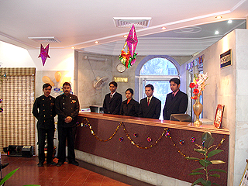The front office as receptionist is an where visitors arrive and first encounter a staff at a place of business. Front office staff will deal with whatever question the visitor has, and put them in contact with a relevant person at the company. Broadly speaking the front office includes roles that affect the revenues of the business. The team front office In contact to the term back office which refers to a company’s operations, personnel accounting, payroll and financial departments which do not interact directly with customers.   
  
**Front office Terminology**   
**Walk ins**  
- A guest who arrives at a hotel without a reservation.  
  
**Cancellation**  
- Indicates the date when the reservation was manually cancelled.  
  
**Credit Allowance**   
- Reversal of charges which was posted before current system/ PMs date.  
  
**No shows**  
- A guest who made a room reservation but did not register or Check in.   
  
**Early Arrivals**- Guest who are arrive early from the check in time.  
  
**House Limits**  
- A limit assigned by the hotel to guest or company accounts.  
  
**Overstays**  
-Guest who are extended stay from their check out date

**Under stays**   
-Guest who are check out earlier from their expected check out date

**Housekeeping**

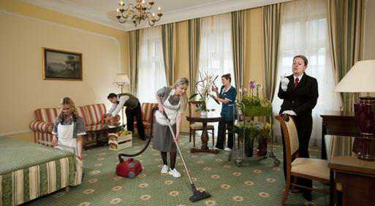

The definition of housekeeping is doing basic cleaning tasks in a house, hotel or other locations or the department of employees who manage and perform cleaning tasks. An example of housekeeping is the cleaning of your bathroom. An example of housekeeping is the maid in the hotel who cleans rooms.

***Duties of the Housekeeping personnel***  
Executive Housekeeper  
-Does not draw attention until a problem or deficiency occurs.  
-Supervising the housekeeping staff, hiring and training of new employees.  
-Ensure hotel’s standard for cleanliness, neatness and sanitation and maintained in guest rooms and public areas, lobby, elevators, halls.  
-Purchases and maintains  
-Furnishing equipment  
-Housekeeper: Clean the guest room & Day shift  
  
Housekeeping Staff   
-Clean guest room  
-cater late arrivals, turn down service  
-house person: Clean public area  
-Utility workers: Distributing cleaning and guest room supplies, minor maintenance, for example: Replace bulb.   
Large enough to handle the hotel’s needs but small enough to avoid reducing profits.

Housekeeping Status  
-VC: The room is vacant and clean  
-VR: The room is vacant and ready  
-OD: The room is occupied

-OOO: The status of the guestroom is not being rentable due to the repaired or under maintenance.   
-Room Check: Inspect the room whether it is follow the SOP procedure to update the status of the room.

**Food and Beverage**

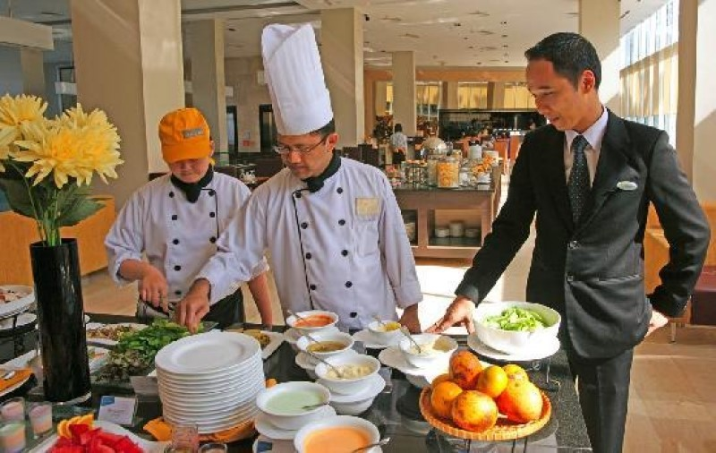

Many travelers judge the overall quality of a hotel by its F&B service. A good food and beverage operations provides a service both to guests of the hotel and the community (outsiders).   
  
-Restaurant   
-Food preparations  
-Food service  
-Beverage service  
-Room service, banquet/catering service  
  
Four important functions of Food and Beverage department are:  
-Generating additional profits for the hotel  
-Providing food & beverage service to guests  
-Controlling costs  
  
**Staff and support departments**This department is more focusing on the employee’s welfare and to train them be more enthusiastic and responsible in their job. This also more important to the hotel industry in order to motivate their staff and to focus their job as well.

**Classify hotels by type, price and location  
Hotel Classifications**By Price : Limited Hotels, Full services hotel, Luxury Hotels.  
  
By Function: Commercial & Convention   
  
By Location: Suburban, Downtown, Highway/interstate, Airport  
  
By Market Segment: Executive conference center, Resort, Casino Hotels, Health Spas  
  
Other:   
  
  
**Limited Service Hotels**Small to medium- sized hotel establishments that offer a very limited amount of onsite amenities and often only offer basic accommodation with little to no services, these facilities normally only cater and market to a specific demographic of travelers, such as the budget- minded traveler seeking a “no trills” accommodation. Limited service hotels often lack an on-site restaurant but in return may offer a limited complimentary food and beverage amenity such as on-site continental breakfast service.  
  
**Full service hotels**Full service hotels often contain upscale full-service facilities with a large volume of full service accommodations, on-site full service restaurants and a variety of on-site amenities such as swimming pools, a health club, children’s activities, ballrooms, on-site conference facilities, and other amenities. Examples include: Holiday inn, Sheraton, Westin, Hilton, and Hyatt hotels.  
  
**Luxury Hotels**  
An upscale full service hotel facility that offers luxury amenities, full service accommodation, on-site full service restaurants and the highest level of personalized and professional service. Luxury hotels are normally classified with at least a Four Diamond status or a Four or Five Star rating depending on the country and local classification standards. Examples may include: Intercontinental, Four seasons, Conrad, Fairmont.   
  
**Commercial Hotel**A hotel for transients that caters especially to salesman as by providing rooms for the display of samples.  
 **Convention Hotel**A convention center (American English: Conference center outside the USA) is a large building that is designed to hold a convention, where individuals and groups gather to promote and share common interest. Convention center typically offer sufficient floor area to accommodation several thousand attendees.

**Suburban Hotel**A hotel that is somewhat smaller than a city center hotel (typically 250,000 rooms), is usually part of a chain and has bars, restaurants, and other amenities found at city center hotels. Types of suburban hotel are Motel.   
  
**Downtown Hotel**The lower part or the business center of a city or town, adverb. To toward or in the lower part or the business center of a city or town, adjective. Of relating or located downtown.   
  
**Highway Hotel**Hotel that situated doing the roadside or highway.  
  
**Airport Hotel**  
A hotel near the airport. The hotel does not have to be connected to the airport (although some are) even adjacent to it, it could be located up to five miles away. Most airport hotels have a shuttle and from the terminals.   
  
**Define hotel franchising and management controls**

**Hotel franchising**A Franchise is the right to use the brand and the business model of a specific parent company for a prescribed period of time. It is a method for expanding a business and distributing products and services through a licensing relationship. A Franchisor is a company that ‘gives’ the license to a third party for the conducting of a business under their trademark. They specify the products and services that should be offered. A Franchise is a company who ‘uses’ the license of the franchisor to do business under his trade name, according to terms and conditions of the contract. In other words it means that the parent company’s name (brand) and products. A Franchise can be owned as a corporation, sole proprietorship, Limited Liability Company or other business structure. In hospitality industry, a Hotel Franchise can be vaguely compared to a chain, since it is a management agreement that provides certain services (brand reservation system, support etc,) in return to follow specific regulations and procedures. In other wards the hotel brand is shared by other proprietors. Beneficial is that the Franchise can brand their hotel with a well- known and popular brand, while the franchise contract provides them with a powerful set of tools to drive new business. Franchisees operate business for themselves but not by themselves.

**The advantages of a Hotel Franchise (for the Franchisees) are:**   
-Strong brand portfolio   
-Specific set of tools  
-Strong approach to standards  
-good reputation  
-training programmes  
-consultation and advice service  
-marketing programmes  
The benefit for the franchisor, on the other hand, is an alternative to building “chain stores/hotels to distribute their products. It avoids the investments and liability of a chain.

**Management Contract**   
A management contract is an arrangement under which operational control of an enterprise is vested by contract in a separate enterprise that performs the necessary managerial functions in return for a fee. Management contracts involve not just selling a method of doing things (as with franchising or licensing) but involve actually doing them. A management contract can involve a wide range of functions, such as technical operation and of a production facility, management of personnel, accounting, marketing services and training.   
  
**Difference between Franchising and Management Contract**In business management, franchising is a contractual relationship between franchiser (owner of the company) and franchisee (buyer of a brand name). The franchiser allows the franchisee to use its trademark along with certain business systems and processes in exchange for a fee. Business students usually get confused between the concepts between the concepts of management contracts and franchising. Although thy have much in common, such as both of them earn by selling intangibles and are both affiliated with another company, but where a management contract acts as a framework and provides formation an independent businessman.

**Question 4**

Explain the Significant of Entertainment in this industry

Recreation, leisure and wellness

Recreation

* Recreation or fun is the expenditure of time in a manner designed for therapeutic refreshment of one’s body or mind
* All kin of sport activities, indoor or outdoor. Basic component of individual, social behavior and aspiration.

Leisure

* Leisure or free time, is a period of time spent out of work and essential domestic activity
* The period of recreational and discretionary time before or after compulsory activities such as eating and sleeping, going to work or running a business, attending school and doing homework, house whole chores and day-to-day stress.

Wellness

* A health club ( also known as a fitness club, fitness center, and commonly referred to as a gym) is a place which houses exercise equipment for the purpose of physical exercise
* A sauna is small room or house designed as a place to experience dry or wet heat sessions, or an establishment with one or more of these and auxiliary facilities.

Government sponsored recreation

Various levels of government that constitute government-sponsored recreation are intertwined, yet-distinct, in the parks, recreation and leisure services. Government raises revenue from income taxes, sales taxes, and property taxes. Additionally, government raises special revenue from recreation-related activities such as automobile and recreational vehicles, boats, motor fuels transient occupancy taxes (tot) on hotel accommodation and etc.The monies are distributed among the various recreation and leisure-related organization at the federal, state/provincial, city and town levels.

**Commercial recreation**

Commercial recreation – often called eco or adventure tourism- provides residents and visitors with access to an area’s spectacular wilderness through a variety of guided outdoor activities.

It can be divided into three categories which are:

* Theme parks

Example: Legoland

* Attraction

Example: island and mountain

* Clubs

Theme parks

Theme parks atmosphere are concentrated on one dominant the theme such as;  
Architecture, landscaping, costumed personal, rides, shows, food services and merchandise.  
Theme park concept is significant to coordinate and attractions vary according to theme which might base on: historical, culture, geographical, and so on.

Clubs   
Private clubs are places where member gather for social, recreational, professional, and fraternal reasons.  
Many clubs are designed around a housing development where the neighborhood can utilize the services of the clubs (golf, tennis, pool).

**Noncommercial recreation**

**Voluntary organization**, which are nongovernmental, nonprofit agencies, serving the public at large or selected elements with multiservice programs that often include a substantial element of recreational opportunity

**Campus recreation** programs include involvement by campus recreation offices, intramural departments, student unions, residence staffs or other sponsors.

**Armed forces recreation** provides well-rounded welfare and recreational programs for military personnel

**Employee recreation** promotes employee efficiency through recreational activities

**Recreation for special populations** involves professionals and organizations who serve groups such as those with mental illness, mental retardation or physical challenges

Types of recreation clubs

* Private club  
  Only members or the elite group gather for their social, recreational professional or fraternal reasons.
* Club management  
  Similar to hotel management. The differences are the guest feel as if they are the owner most of the time they do (emotional attachment is stronger than the hotel guests). Clubs don’t offer sleeping accommodation.
* Country club  
  Offers recreational facilities, golf, tennis, swimming, horseback riding, pool rooms and etc. Club Monterez, Denai Alam Recreation & Riding Center.
* City Club  
  Business oriented, clubs that fall under this category are professional, social,athletic, dining, university, military, yachting, fraternal, properties and etc. Example, Marinas & yatch clubs, The Marina Penang Yacht Club, Royal Langkawi Yatch Club.

Gaming Entertainment Industry   
Gaming entertainment refers to one subset of gaming industry, namely the casino industry. This includes both the land based and cruise line.   
  
**Gaming**  
-Entertainment offers games of risk only as part of the total package of entertainment and leisure time activities.  
-The customer serve base as ‘social gambler’ who play a game of risk as a form of entertainment and social activity or combining gambling with other activity during their visit.  
-One stopped packages business, compress theme parks, hotels, retail shopping, casinos. Example , Genting Highlands.  
  
**Gambling**-Is playing game of risk for a thrill of the “action” and chance of making money.  
-The most happening and glamorous Gambling industry in Las Vegas in USA as well in Europe.  
-Although gambling is prohibited in most country, yet the government of most countries allow gambling after abiding with certain guidelines and rules imposed by the government. Also, due to the fact that gambling contribute one-third of the major center for revenue and tax collection.   
  
**Position in Gambling Entertainment**

* Hotel Operations  
  - Rooms and guest service department
* Food and Beverage Operations  
  -Restaurants, room service, banquets and conventions, retail outlets
* Casino Operation  
  -Gaming operation staff, slot machine technicians, table game dealers, table game supervisors. Service staff, purchasing, maintenance engineers, Marketing & HR & Finance & admin staff.
* Retail Operations  
  -An overlooked career path in the gaming entertainment industry. Example in all phases of retailing operation, store design, layout to production selection, merchandising, sales.
* Entertainment Operations  
  -Professional entertainment staff, live entertainment, stage and theatre productions, lighting and box office management, talent management.

**Conclusion**

At my perception, to be called at the end, I learned and covered about tourism and hospitality industry. Tourism is a dynamic and competitive industry that requires the ability to adapt constantly to customer’s changing needs and desire, as the customer satisfaction, safety and enjoyment. Hospitality is all about providing food, drink and accommodation. It’s also involves entertainment, fitness and leisure workers.  The hospitality industry is much broader than the other industries. It is also known as the largest and fastest growing industry in the world. One of the most exciting aspect of this industry is that it is made up of variety profession. The hospitality and tourism industry is diverse and includes many location including RV parks, food establishment, recreational facilities, camp grounds, boarding houses and youth hostels. As a concept has come a long way today and the activity has been classified into various categories. The different categories of tourism such as cultural tourism, religious tourism, adventure tourism and much more.  What is lodging accommodation? It is companies that can develop by its own, manage and operate lodging facilities including motels and full services hotels, usually out in nature, often made from logs, woods or other natural material. Accommodation facilities play a very important role in popularizing any tourist’s destination. The form of low budget lodges or hotels to world class luxury hotel also available at all the major tourist destination to provide the tourists a home away from home. Entertainment is a form of activities take a way people stress basically come from school or work and give properly amusement to relax. In tourism industry entertainment is an important sector. Tourists would love to visit some specific place such movie theatres, Water Park, carnival and further more.

**References**

1. Wikipedia

<https://en.m.wikipedia.org/wiki/Tourism>

1. Mike joseph ( Jul 7, 2015) Tourism ( importance)

<https://www.slideshare.net/mobile/MikeOdias/tourism-importance-of-tourism>

1. Angela Francisco ( Apr 19, 2015) Meaning of tourism

<https://www.slideshare.net/mobile/JhelleEnFrances/meaning-and-importance-of-tourism>

1. Herasquivel ( oct 7, 2014) Introduction to Hospitality industry

<https://www.slideshare.net/mobile/heraesquivel/introduction-to-hospitality-industry-39956160>

1. Sunil kumar (Dec 9, 2013) introduction to hospitality

<https://www.slideshare.net/mobile/SunilKumar148/all-fb-1-yr-basics>

1. The tourism society

<http://www.tourismsociety.org/page/88/tourism-definitions.htm>

1. Ennaira Saint ( July 4, 2014) Sector of tourism

<https://www.slideshare.net/mobile/enairrasaint/sectors-in-tourism>

1. Althin Bak0 ( July 21, 2013) Types of tourism

<https://www.slideshare.net/mobile/ALTINBAKU/the-different-types-of-tourism>

1. Tourism Council

<http://www.tourismcouncilwa.com.au/2016-categories>

1. Charlie Zabala ( Jan 26, 2015) Lodging accommodation

<https://www.slideshare.net/mobile/charliezabala7/lodging-accommodation>

1. Nicoleh Walter (Dec 2 , 2014) Lodging Industry

<https://www.slideshare.net/mobile/nicolehaywalters/chapter-1-the-lodging-industry>

1. Blurtit

<http://science.blurtit.com/1077445/what-is-the-importance-of-tourism-industry>

1. Wikipedia

<https://en.m.wikipedia.org/wiki/Hospitality>

1. Wikipedia

<https://en.m.wikipedia.org/wiki/Hospitality_industry>

1. Encyclopedia

<http://www.encyclopedia.com/history/dictionaries-thesauruses-pictures-and-press-releases/hotels-and-hotel-industry>

1. Michelle Reynolds categories in hospitality industry

<http://smallbusiness.chron.com/three-categories-hospitality-industry-58524.html>

1. Roma Gandhi ( July 22,2016) introduction to hotel industry

<https://www.slideshare.net/mobile/RomaGandhi3/introduction-to-hotel-industry-64288793>

1. Anamena (Jan 28, 2015) types of accommodation

<https://www.slideshare.net/mobile/anamena78/types-of-accommodation-43990556>

1. Roopeshv ( feb 24, 2015) entertainment

<https://www.slideshare.net/mobile/roopeshv149/attraction-shopping-entertainment-components-of-tourism>

**Appendix**



Figure 1 shows the meaning of tourism adapted from trishty khandelwal Published on Apr 23, 2015.



Figure 2 shows the meaning of hospitality adapted from lecture Sunil Kumar Published on Sep 6, 2013.



Figure 3 shows the understanding about hospitality.



Figure 4 shows example of front office in hotels.



Figure 4 shows example of housekeeping.



Figure 5 shows the example of F&B in Hotels.

Thank You.